# React

# 4.ReactJS-HOL

# Mandatory HandsOn

**1.Create a new react application using *create-react-app* tool with the name as “blogapp”**

npx create-react-app blogapp

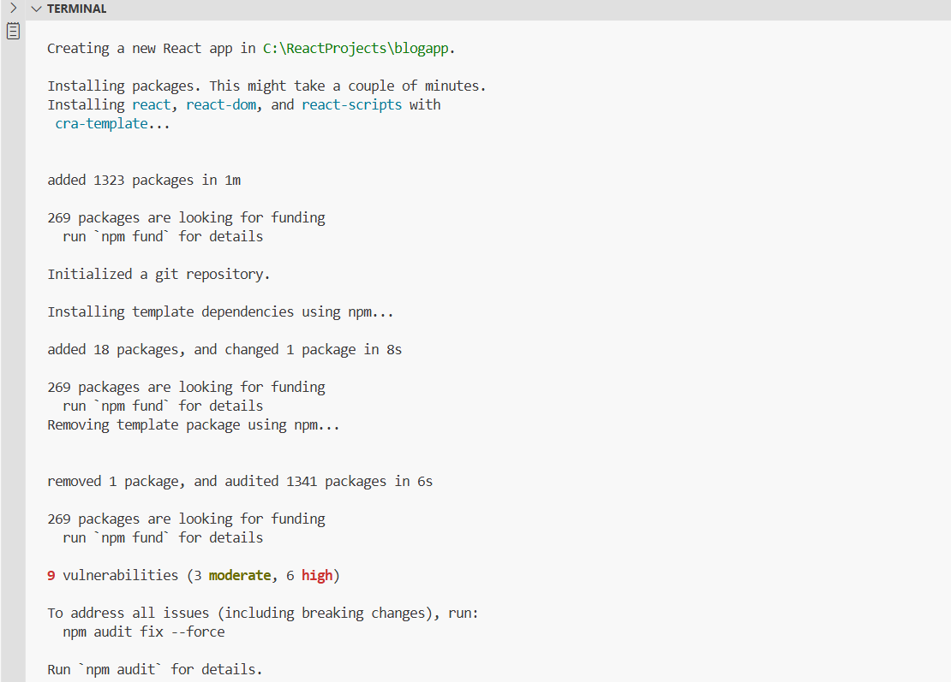

2.Open the application using VS Code

cd blogapp

code .

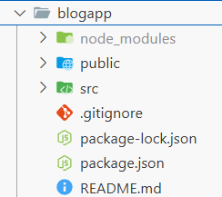

3.Create a new file named as **Post.js** in **src folder** with following properties

**Post.js**

class Post {

constructor(id, title, body) {

this.id = id;

this.title = title;

this.body = body;

}

}

export default Post;

4.Create a new class based component named as **Posts** inside **Posts.js** file

**Posts.js**

import React from 'react';

import Post from './Post';

class Posts extends React.Component {

constructor(props) {

super(props);

this.state = {

posts: [],

error: null

};

}

loadPosts() {

fetch('https://jsonplaceholder.typicode.com/posts')

.then(response => response.json())

.then(data => {

const postList = data.map(p => new Post(p.id, p.title, p.body));

this.setState({ posts: postList });

})

.catch(err => {

this.setState({ error: err.message });

});

}

componentDidMount() {

this.loadPosts();

}

componentDidCatch(error, info) {

alert("An error occurred: " + error.message);

}

render() {

const { posts, error } = this.state;

if (error) {

return <div>Error: {error}</div>;

}

return (

<div>

<h1>Posts</h1>

{posts.map(post => (

<div key={post.id}>

<h2>{post.title}</h2>

<p>{post.body}</p>

<hr />

</div>

))}

</div>

);

}

}

export default Posts;

5.Add the Posts component to App component.

**App.js**

import React from 'react';

import Posts from './Posts';

function App() {

return (

<div className="App">

<Posts />

</div>

);

}

export default App;

6.Build and Run the application using *npm start* command.

npm start

